Long Term Data Analytics with Tableau
Project Documentation format
1. Introduction
• Project Title: Heritage Treasures: An In-Depth Analysis Of UNESCO World Heritage Sites In Tableau
• Team Members:
Team Leader : Battula Bala Sai - Data Analyst – Data collection, cleaning, preprocessing
Team member : Dhanunjay Prabhakar Mugata - Tableau Developer – Dashboard & story development
Team member : Immaneni Karthik - Documentation Lead – Report preparation & testing documentation
Team member : Jakkula Kavya - QA & Testing – Performance testing and validation

2. Project Overview
• Purpose:
The purpose of this project is to analyze global heritage data from UNESCO and visualize insights about World Heritage Sites using Tableau.
The project aims to:
- Identify country-wise and continent-wise distribution of heritage sites
- Analyze trends over years of inscription
- Compare Cultural, Natural, and Mixed heritage sites
- Highlight sites categorized as “In Danger”
- Provide an interactive platform for exploring heritage data

Features
- Interactive world map visualization
- Country-wise and continent-wise comparison charts
- Year-wise growth trend analysis
- Cultural vs Natural vs Mixed site comparison
- Endangered sites identification
- Dynamic filters (Country, Continent, Year, Category, Status)
- Story mode for guided data presentation
- KPI indicators showing total sites and percentage distributions
3. Architecture
Frontend
The frontend is developed using:
- Tableau Public for dashboard visualization
- Interactive charts, maps, filters, and story presentation
- Responsive layout for different screen sizes
- User-driven filtering and drill-down analysis
The frontend displays processed heritage data visually and allows users to explore insights interactively.

Backend
The backend is developed using:
- Flask
Backend Responsibilities:
- Load and preprocess UNESCO dataset
- Clean missing and inconsistent values
- Prepare structured data for visualization
- Provide processed dataset to Tableau
Since this is primarily a data visualization project, backend functionality is minimal and mainly supports data handling.

Database
- Data Source: Kaggle UNESCO World Heritage Dataset
- Format: CSV file (whc-sites2019.csv)
- Preprocessing Tool: Excel / Python
Database Schema Includes:
- Site Name
- Country
- Region / Continent
- Category (Cultural / Natural / Mixed)
- Year of Inscription
- Area (Hectares)
- Latitude & Longitude
- Danger Status
Data is cleaned and structured before importing into Tableau for visualization.
4. Setup Instructions
Prerequisites
- Python (3.x)
- Flask
- Tableau Desktop / Tableau Public
- Excel or Google Sheets
- Kaggle dataset download
Installation Steps
- Download the dataset from Kaggle.
- Install required Python packages:
pip install flask pandas
- Place dataset in project directory.
- Run preprocessing script (if applicable).
- Open Tableau.
- Connect Tableau to cleaned CSV file.
- Open the dashboard file (.twbx).
- Start exploring visualizations.

5. Folder Structure
• 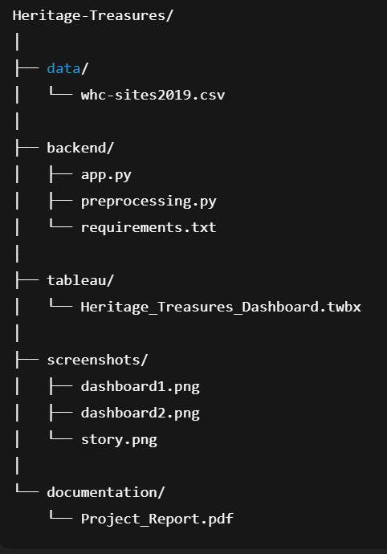.
6. Running the Application
Backend
- Navigate to backend folder:
- python app.py
- Flask server will start on:
- http://127.0.0.1:5000
Frontend
- Open Tableau.
- Load the .twbx file.
- Interact with filters and dashboards.

7. API Documentation
• Although the project primarily focuses on data visualization using Tableau, a lightweight backend was developed using Flask to manage dataset access.
8. Authentication
• Currently, the project does not implement authentication.
If deployed as a web application:
- Basic token-based authentication can be implemented using Flask.
- Public dashboard access via Tableau Public does not require login.
9. User Interface
The UI consists of:
- Dashboard 1: Global Overview (Map + KPIs)
- Dashboard 2: Category & Country Comparison
- Story View: Guided analysis presentation
10. Testing
Testing Strategy
- Data validation testing
- Filter functionality testing
- Dashboard responsiveness testing
- Cross-browser testing
- Performance testing (load time & interactivity)
Tools Used
- Tableau Desktop
- Excel
- Python (for validation)
11. Screenshots or Demo
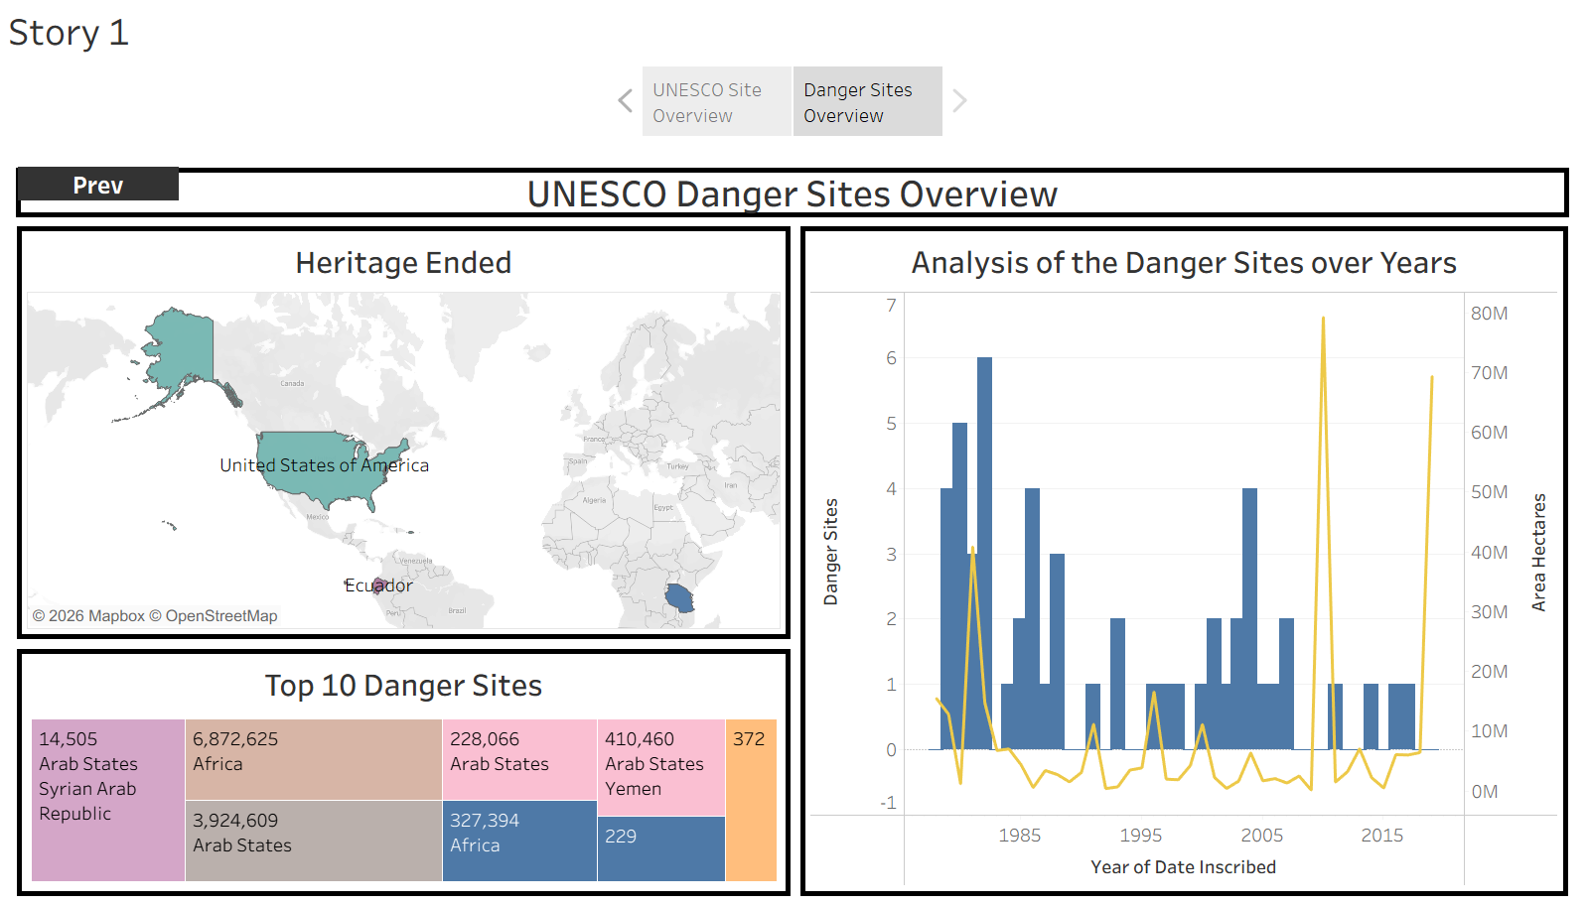
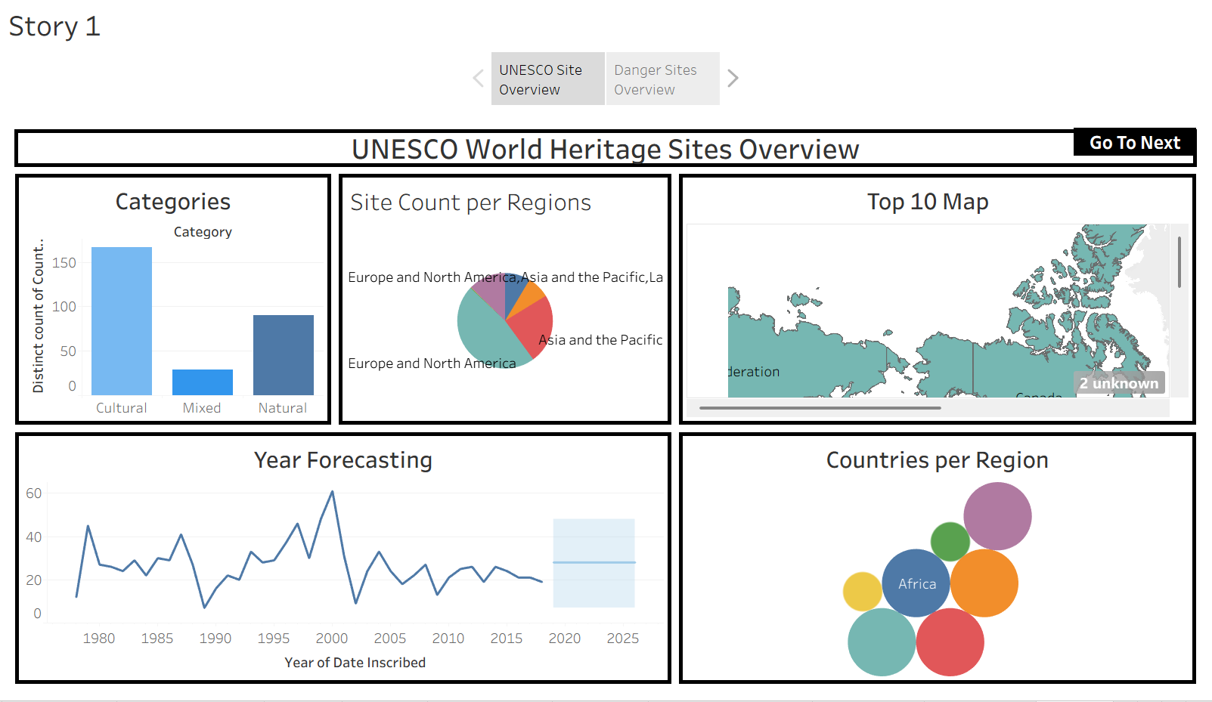
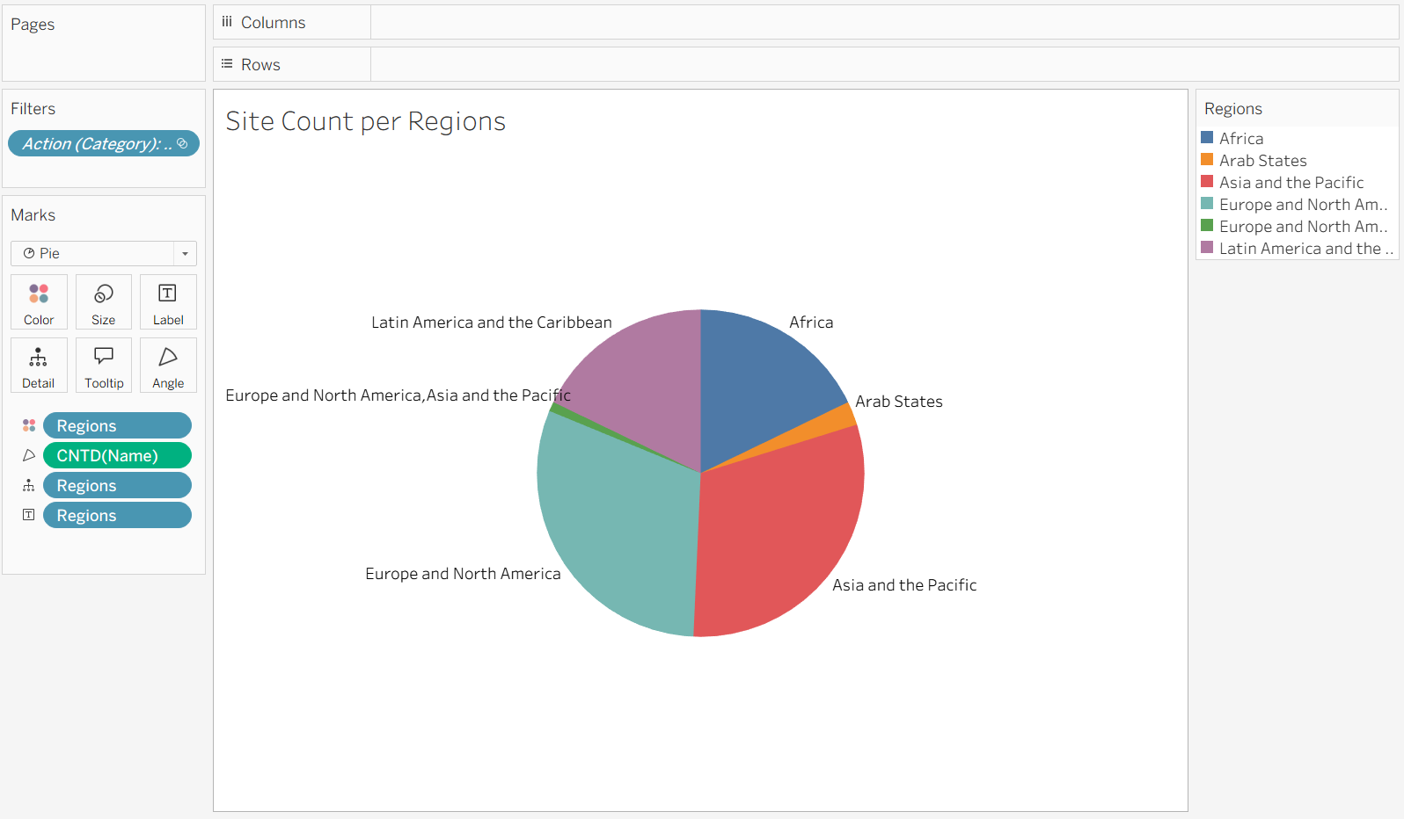

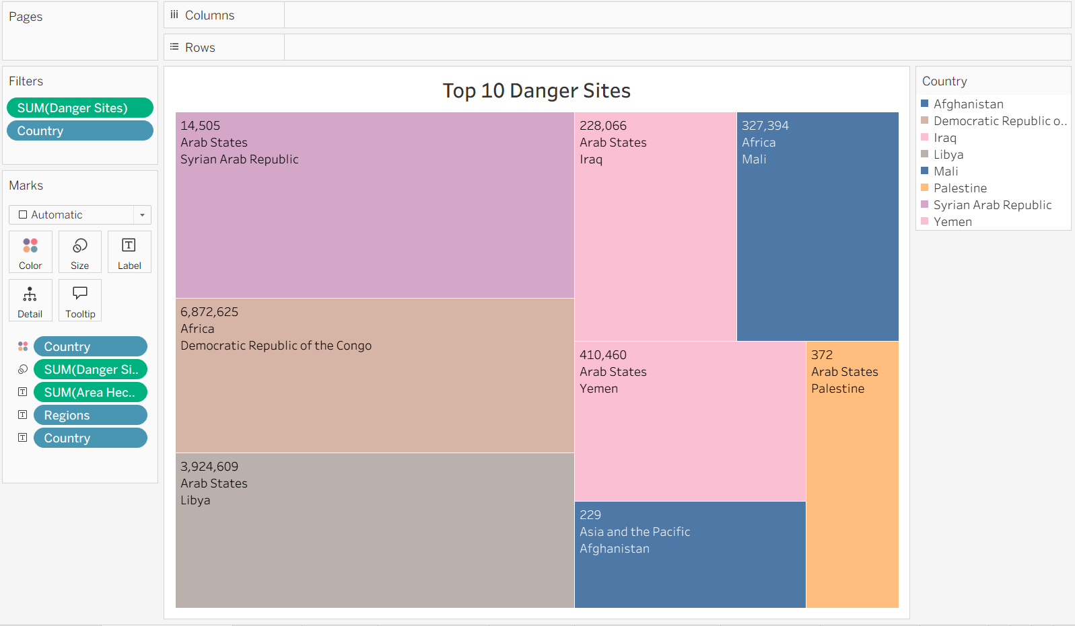
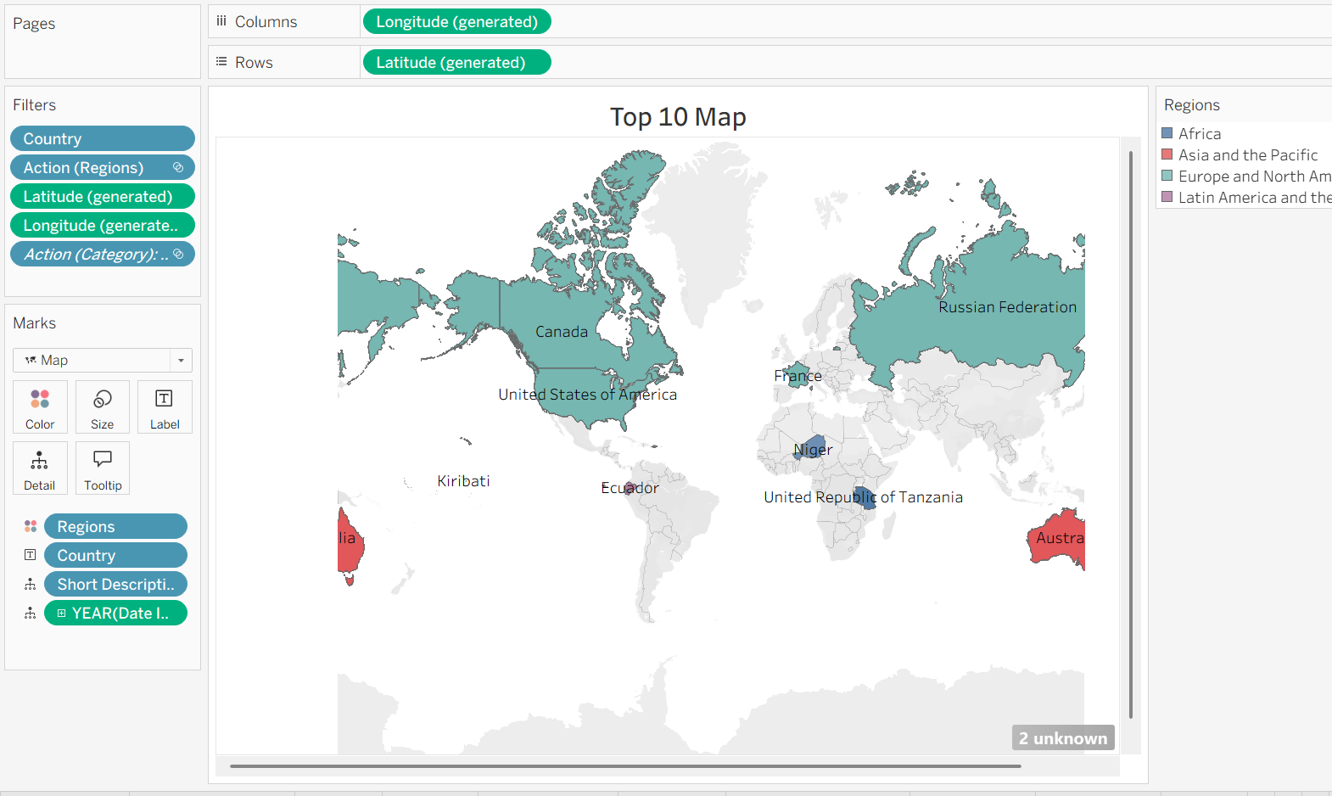
12. Known Issues
• Dataset is static (not real-time updated)
• Some heritage sites have missing area values
• No predictive analytics implemented
• Dependent on accuracy of source dataset
13. Future Enhancements
- Integration with live UNESCO APIs
- Real-time updates
- AI-based prediction of endangered sites
- Tourism data integration
- Mobile-friendly web version
- Interactive storytelling enhancements

